Sexual Harassment Policy
This policy template has been created by SoundCheck Aotearoa to provide a tool to help organisations and people in the music community to create their own Sexual Harassment Policy. This policy is based on the WorkSafe policy, but takes into account some factors that are specific to the music industry in Aotearoa. In some areas this template goes further than the WorkSafe policy, but does so in order to address concerns that the music community have expressed during hui and training run by SoundCheck Aotearoa. This template only addresses sexual harassment – but please note WorkSafe also recommends PCBUs have a policy on bullying (and have an example on their website).
Who should use this template?
This template is drafted in the “plural” to work for PCBUs that have more than one worker.
If you are a sole trader or small business that doesn’t have workers you may need to adapt some sections of this policy and language so they accurately reflect how you or your business operates – alternatively, you may choose to use the Workplace Conduct Policy - Short Form template available here.
If you are self-employed but only as a “worker” for other organisations, then you may not need your own policy but can talk to those you work with about whether or not they have a policy and, if not, you could use this template to help them create one.
Who does a policy apply to?
The policy you create will apply to you and any workers you employ or engage - this includes employees, contractors, crew, casuals, labour hire and volunteers. This template refers to this broad group of people as "workers" as that is the term used in the health and safety legislation.
In the music industry, it is common for many different PCBUs to be working together. When this happens there are shared health and safety duties which require PCBUs to consult, co-operate and coordinate their activities (see additional information on overlapping duties on the SoundCheck Aotearoa website).
Your policy will always apply to your workers whenever they are working with you. However, when there are overlapping duties, other PCBUs (including the one engaging you and/or other PCBUs with influence or control over the work) may also have policies that you and your workers will need to comply with. This means that, when working or collaborating with others, more than one policy may apply at a time. You need to cooperate with those PCBUs to clarify policies, procedures, roles, responsibilities and actions and communicate those to your workers. What this means in practice will depend on the circumstances, however this is why consultation, communication and cooperation is essential in any situation where there are overlapping duties.

How to use this template
We encourage you to take this suggested policy and make it your own – you might use this one as a base, you may want to go further than this policy, and/or put it in language that you think will work for you and your crew. If you already have a sexual harassment policy, or a policy covering both bullying and harassment, you may still find it useful to review this template and consider whether you should update the sexual harassment sections of your policy. This is not meant to be a 'one-size-fits-all' document for the industry; rather, it is a resource to help anyone in the industry create their own policy.

The document also includes ‘Guidance notes’ in yellow boxes and [square brackets] to give you more information. You should delete all guidance notes and this first page before using this policy. You can delete the yellow guidance boxes by clicking on them and deleting.

CONTENTS
Sexual Harassment Policy 4
Purpose of policy 4
Who is covered by this policy? 4
When and where does this policy apply? 4
What is sexual harassment? 5
What does “unwelcome or offensive” mean? 6
Consent and power imbalance in the workplace 6
Prevention: Roles and Responsibilities 8
Bystander interventions 10
Response - Options for people with concerns about sexual harassment (including the Complaints Process) 12
Introduction 12
Options for people experiencing or seeing sexual harassment 12
Who you can report to internally 13
Options after a report has been made 14
What we will do after a report has been made 15
Formal investigation process 16
Anonymous reports 17
What if the process has not addressed your concerns? 18
Support, advice and information 18
Policy Review 19
Appendix 1: Flowchart 21
Appendix 2: Reporting form 22

Sexual Harassment Policy

Purpose of policy
[YOUR NAME/COMPANY] is committed to creating an environment where everyone feels safe, included and welcome, and that is free from sexual harassment. To achieve this aim [YOUR NAME/COMPANY] expects everyone who works with us to comply with this policy and treat everyone with respect.
GUIDANCE: This section of the policy sets out your position and “sets the tone” about sexual harassment prevention and response for those who work with or for you. If you have a kaupapa or value statement for your business you can include it here.
This policy sets out:
- the minimum standards for creating and maintaining a safe working environment
- the respective responsibilities of everyone that works with us to prevent sexual harassment and harm at work
- how [YOUR NAME/COMPANY] will respond if sexual harassment does occur in our work or workplace - including the options available if this happens to you

Who is covered by this policy?
This policy applies to all people engaged to work with [YOUR NAME/COMPANY], whether engaged as an employee, crew, contractor, subcontractor, freelancer, casual, labour hire or a volunteer. In this policy, we will call everyone the policy applies to “workers”. This policy will also apply to visitors to our workplaces, including someone we are collaborating with (even if they are not a worker), audience members, guests or members of the public.
This policy will always apply when workers are working with [YOUR NAME/COMPANY]. In some situations when you are working with us, we may also be collaborating with or working alongside other companies and organisations and they may have additional safety policies, procedures or safety measures that will apply to that work. We will co-operate with those companies and organisations to clarify expectations of all parties, and clearly communicate those to our workers.
GUIDANCE: A sexual harassment policy applies at your workplace (wherever that is), at work events and outside the workplace if related to work.

The following section includes examples of workplaces and situations where the policy may apply but you do not need to include all examples and you should tailor the examples to suit your business.

When and where does this policy apply?
This policy applies whenever and wherever you are working with us, or if there is a situation that is related to or impacts your work with us. In our industry, this can cover a wide variety of places and situations – including:
- at our workplace and/or any space where we may be working – including in offices, at venues, festivals, onstage, backstage, recording studios, creative/collaborative spaces, clubs, pubs or bars
- in ‘private’ spaces such as production offices, green rooms, artist only areas, or private homes (wherever it’s related to work)
- when on tour or travelling for work – including in vehicles, other transport or accommodation
- at work related events, wherever they may occur, such as award events, after parties and/or socialising around or after work
- in online communications, such as virtual meetings/seminars and private messages with other workers and within industry social media groups.
If you are unsure if this policy applies to a situation you are concerned about, please err on the side speaking to someone about it (see the options available in the Response section of this Policy).

What is sexual harassment?
GUIDANCE: this wording summarises the legal definition of sexual harassment under the Human Rights Act 1993 and Employment Relations Act 2000.
Sexual harassment is defined in workplace legislation as:
- directly or indirectly asking for any other person for sexual intercourse, sexual contact or other form of sexual activity with:
- an implied or overt promise of preferential treatment in their current or future work, or
- an implied or overt threat of detrimental treatment in their current or future work,
OR
- any unwelcome or offensive sexual behaviour that is
- repeated, or
- of such a significant nature to have a detrimental effect.

Sexual harassment can happen to and by someone of any gender. It can be direct or indirect. It can involve language (written, spoken or non-verbal such as whistling or grunting); visual material (e.g. pictures, photos or videos); and/or or physical or non-verbal behaviour (gestures, touching, indecent or inappropriate behaviour).
People do not invite sexual harassment by virtue of things such as their clothing or not speaking up when the behaviour occurs.
Some sexual harassment can be a breach of both workplace legislation and also a criminal offence, e.g. ‘groping’ is sexual harassment and is also a criminal offence of indecent assault.
It is also worth noting that some workplace behaviour (e.g. a one-off wolf whistle) may not meet the legal definition of sexual harassment but can still be inappropriate in a workplace. Such behaviour can contribute to a disrespectful or unhealthy work environment, in which sexual harassment and/or criminal offences are more likely to occur, and can still be reported to us.
For examples of sexual harassment, please see the Continuum of Workplace Behaviours attached to this policy.
GUIDANCE: This template refers to attaching the Continuum of Workplace Behaviours because that is covered in SoundCheck Aotearoa Professional Respect training days. If you choose to use the Continuum, it can help people understand the range of acceptable and unacceptable behaviours. If you do not want to attach the Continuum to support your Policy you should delete these sentences and delete the Appendix containing the Continuum.

What does “unwelcome or offensive” mean?
“Unwelcome” behaviour is behaviour that is not wanted or invited.
Whether behaviour is unwelcome or offensive is judged from the perspective of the person experiencing the behaviour.
There is no obligation to tell the person concerned that the behaviour is unwelcome or offensive.
Behaviour may still be sexual harassment even if the person did not intend to sexually harass someone or was unaware that their behaviour was offensive.

Consent and power imbalance in the workplace
Consensual sexual activity or consensual intimate relationships will not be considered sexual harassment, however we all need to be aware of what consent looks and sounds like.
A person cannot consent to sexual activity if they are forced, threatened or coerced, when they are too intoxicated, or do not understand what or who they are consenting to, or if they are underage.
Consensual sexual activity or intimate relationships may be inappropriate where there is an imbalance of power between the people involved and/or where it gives rise to a conflict of interest.
A power imbalance can result from things like gender, sexuality, ethnicity, minority status, age, dis/ability, seniority, or influence in the workplace.
Power imbalances in the workplace can contribute to sexual harassment or inappropriate behaviour occurring and people being less likely to report it. As a result, we should all be cautious and mindful of our position when considering whether to act on mutual attraction in a work context.
GUIDANCE: If you wish to include more specific policy guidance in the above section, you can select and paste in one of the following options. You may also tailor any of the options to suit your workplace.
Option 1 - If sexual activity or an intimate relationship happens within the work context, we ask you to commit to having an open dialogue at an early stage so that we can agree how to manage any conflicts of interest, power dynamics and/or the impact on others. Where sexual activity happens and there is an imbalance of power in the relationship, the person with power in the relationship will be responsible for disclosing.
Option 2 – In our workplace, we discourage sexual activity and intimate relationships between people who work together. If it does happen, the sexual activity or intimate relationship will need to be disclosed to [Identify appropriate person/roles in your workplace] at the earliest opportunity and we will make appropriate changes to any working relationship or arrangements to manage the power imbalance, conflicts of interest and/or potential impacts within the workplace. Where sexual activity happens and there is an imbalance of power in the relationship, the person with power in the relationship will be responsible for disclosing.
Option 3 – In our workplace, [identify which people/roles with power relationships you want to prohibit – e.g. Managers] must not have sexual activity or an intimate relationship with someone they have influence or control over in work that they do.

Prevention: Roles and Responsibilities
As with all health and safety matters, everyone has a role and responsibilities in preventing sexual harassment.
[YOUR NAME/COMPANY] will undertake the following:
Culture, Leadership, Policies & Procedure
- Establish and maintain a work culture that does not tolerate sexual harassment and communicate this policy to those we work with.
GUIDANCE: There is a Code of Conduct template on the SoundCheck Aotearoa website, which can be used to help set the tone for your desired culture.
- Encourage and invest in a positive leadership style, and promote harmonious and professional relationships across the organisation and with other suppliers and collaborators.
- When working with other organisations, coordinate with them to ensure there is clear and consistent decision making and communication about the applicable policy, the areas of responsibility, and safety measures being used to prevent and respond to sexual harassment.
- Implement processes for reporting and responding to sexual harassment and regularly review their effectiveness.
- Ensure all workers know what sexual harassment policies and processes are in place – including what support, protection and advice is available, how to report any concerns (internally and externally), the approach to confidentiality, and their right to submit complaints to external agencies.
- Provide regular training and resources to workers and [department heads / managers / supervisors / sexual harassment contact persons] on how to prevent sexual harassment and receive disclosures or complaints – including giving appropriate support.
GUIDANCE: Include applicable leadership roles from your organisation.
It is recommended you provide training at least every year to your workers on sexual harassment, and, for your leaders and other applicable people who may receive disclosures, on how to receive and respond to reports of sexual harassment. This can be done by you in a staff meeting with in-house training, or with an external provider. See Training section of the SoundCheck Aotearoa website for information about training available.
If you do not have regular/permanent staff or crew (e.g. you hire contractors for gigs intermittently) you should tailor this section to set out how you will ensure they have access to appropriate information (for example, you might provide them with resources, and encourage those people to do training between gigs).
- Regularly review the effectiveness of this Policy and our sexual harassment prevention measures – including updating this Policy where needed.
GUIDANCE: This policy should be a document that you regularly consider whether it is effective or if any other improvements are need to the policy or your control measures. Include in this section any ways in which you will do so – e.g. debriefs, surveys, meetings with workers.
Safety measures
- Identify and undertake risk assessments for factors that contribute to sexual harassment (e.g. isolation, power and gender imbalances, alcohol/drugs, blurring of work and social situations) and put effective safety measures in place to eliminate or minimise these risks so far as is reasonably practicable.
GUIDANCE: See example safety measures on SoundCheck Aotearoa website.
- Make supporting material (e.g. sexual harassment prevention posters, referral information) readily available and visible to help create a safe working environment.
GUIDANCE: See example posters and visual resources on SoundCheck Aotearoa website.
- Where applicable, comply with our liquor licensing requirements to manage the risks associated with alcohol, and ensure workers are aware of and trained on how alcohol or drugs may affect consent (see Sexual Harm and Consent section on SoundCheck Aotearoa website).
Responding to reports or disclosures of sexual harassment
- Establish and maintain a culture in which workers feel able to disclose when they have experienced sexual harassment (see Receiving Disclosures pamphlet on SoundCheck Aotearoa website).
- Have a range of informal and formal options available to deal with reports of sexual harassment.
- When a person reports sexual harassment, treat all parties fairly and impartially – including providing support - while allegations are being responded to in accordance with this Policy (see Response section).
- Have clear and appropriate remedies and consequences for situations where sexual harassment or inappropriate behaviour is found to have occurred.
- Treat all reports/disclosure with strictest confidentiality, except where agreed by the people involved or required by the law to do otherwise.
[Heads of Department / Supervisors / Managers] will:
GUIDANCE: include appropriate senior leaders here using your organisation’s terminology.
- Role model positive leadership behaviours that foster a culture where sexual harassment is not tolerated.
- Ensure workers are aware of their rights, and responsibilities, in respect of sexual harassment at work.
- Uphold the organisation's commitment to worker training and provision of resources about sexual harassment prevention and response.
- Address and deal with any inappropriate behaviour before it escalates – i.e. role model bystander interventions (see Bystander interventions section below).
- Take prompt action in response to any report of sexual harassment in a fair and impartial manner and in accordance with the Reporting section of this Policy (including taking into account the preferred approach of the person reporting the concerns).
- Ensure the people involved in any disclosure of sexual harassment (whether making the report or the person the report is about) have access to appropriate support (see Support section of this Policy).
- Treat any reports/disclosures seriously, promptly and with strictest confidentiality (so that the relevant information about a complaint is only provided to those people who need to know about it).
All workers will:
- Treat everyone they work with professionally and respectfully.
- Ensure they understand what sexual harassment is - and be accountable for their own conduct by behaving in a manner that does not sexually harass others.
- Educate themselves about consent and how alcohol and drugs can affect consent – see Sexual Harm and Consent section on SoundCheck Aotearoa website.
- Provided they feel safe and comfortable, tell their [head of department / health and safety representative / supervisor] or a trusted person if they experience or witness any sexual harassment (see options in Reporting Concern).
GUIDANCE: include appropriate roles here for your organisation.
- Provided they feel safe or able to, challenge inappropriate behaviour – this could either be when experiencing it yourself, or when you see someone else experiencing inappropriate behaviour (see Bystander interventions section below).

Bystander interventions
GUIDANCE: Further resources on bystander intervention are available on SoundCheck Aotearoa website.
A bystander is someone who is aware of unacceptable behaviour that is happening to someone else. Bystanders play an important role in dealing with sexual harassment. They can address inappropriate comments and behaviours as they arise, interrupt harassment as it’s happening, and/or support the person experiencing the inappropriate behaviour.
Bystander intervention fosters a safe environment by challenging unhelpful norms and beliefs within your workplace and interrupting unsafe situations.
Everyone can help - whether you are a leader, worker, or seeing inappropriate behaviour happen to anyone (even if you don’t work with them).
Bystander intervention involves five steps:
1. Notice that something is happening.
2. Recognise the behaviour as a problem that requires intervention.
3. Take personal responsibility to do something.
4. Decide how to intervene – e.g. point out behaviour; distract; find someone else to get involved; stay around; check in; support.
5. Intervene safely.
If you are keen to learn more about how you could help as a bystander, the SoundCheck Aotearoa website has more guidance and resources available on bystander interventions.

Response - Options for people with concerns about sexual harassment (including the Complaints Process)

Introduction
We know raising concerns about someone’s behaviour can be daunting, but we strongly encourage anyone to speak up when someone’s behaviour hasn’t met the standard set in this policy, so we can respond to it and take steps to stop it from happening again.
We have a range of options for how workers can raise concerns so that you can choose what you are most comfortable with. You might explore different options at different times (such as an informal option first but a formal option if that doesn’t resolve your concerns). You can report concerns that are current, recent or in the past, and even if you’re no longer working with us. There may be legal limitation periods that apply, and we will raise these with you if applicable.
You can use this process to help you speak up about sexual harassment even if the other person involved does not work with us (e.g. if they were an audience member or work for someone else). In situations where we are working or collaborating with other people, companies or organisations, we may need to co-operate with them to address what has happened – we commit to discussing the proposed approach with you before taking any steps.
This process can also be followed for complaints of other forms of harassment, unreasonable or inappropriate behaviour in the workplace.
Please note that New Zealand legislation states that where someone reports or complaints of sexual harassment in the human rights jurisdiction, no account shall be taken of the sexual experience or reputation of the person making that report or complaint.

Options for people experiencing or seeing sexual harassment
If you experience or see sexual harassment, you can take one or more of the four options set out in this section:
- Seek advice/support
- Deal with it yourself
- Report internally to [YOUR NAME/COMPANY]
- Report externally (to Police, or lodge a complaint with applicable external authority)
You do not have to use these options in this order. In particular, you do not have to deal with it yourself before reporting it to [YOUR NAME/COMPANY] or to an external agency – especially if you do not feel safe or if the behaviour might be a criminal offence and/or repeated.
You can seek advice and support at any stage of the process and in any option.
- Seek advice and/or support
You can:
- talk with a trusted person (e.g. whānau, a friend, trusted colleague) about what happened, options and what support might be needed;
- access confidential support to process what has happened and how you want to respond (see Support for contact details); and/or
- seek advice and support from independent or external sources (such as HELP, Human Rights Commission, unions or a lawyer/advocate).
The SoundCheck Aotearoa website has additional information on where you can seek support and advice, and consider the external options available.
- Deal with it yourself (self-help)
If you feel safe and comfortable, you can approach the other person(s) involved to explain that their behaviour is or has been unwelcome, inappropriate, or offensive, and needs to stop or change (this may include a bystander intervention). This could be in person and/or in writing. You may wish to have a support person when you do this.
You should not approach someone directly about their behaviour if you would feel unsafe or threatened in any way. There is no requirement for you to tell the other person that their conduct is inappropriate.
- Report sexual harassment to [YOUR NAME/COMPANY]
To report sexual harassment, you can make a verbal report (especially if we are working on a job and there is a need for an immediate intervention) or a written report. [YOUR NAME/COMPANY] will take all reports of sexual harassment seriously and will take steps to protect anyone who reports sexual harassment from retaliation.
You can report sexual harassment to us irrespective of when it happened. For example, you can report it after a job has finished and we are no longer working together. Or if you raised a concern to someone at the time it happened, but later you wish to report it to [YOUR NAME/COMPANY] for further follow up.
When making a report, any details you can provide will help. If you want, you can use a reporting form (see Appendix), either by filling in the form or providing that information by email. We encourage you to state what happened, where and when it happened, any witnesses, how it has affected you and what you would like to happen next.

Who you can report to internally
GUIDANCE: Insert below the titles of the people that your workers can report sexual harassment to. We encourage that you have nominated roles/people – which should include people at a range of different levels in the organisation. It is important anyone listed has undertaken training in receiving disclosures of sexual harassment (see training section of SoundCheck Aotearoa website for details of training).

You can report sexual harassment to:
- One of our sexual harassment contact people [add nominated roles that will receive disclosures]
- The [Heads of Department / Manager / Supervisor]
- Our Health and Safety representative
- [Our nominated external sexual harassment contact person/service]
GUIDANCE: The last bullet point allows for the option of you choosing to appoint an external sexual harassment contact person.
If you appoint an independent lawyer/HR consultant, you will need to agree with them their terms of engagement (including fees, the process for receiving disclosures and what they will do with reports they receive and confidentiality). If applicable, you should set out in this section the agreed process, including their contact details and what steps will be followed.

Note that SoundCheck Aotearoa does not provide any form of complaints/reporting service so cannot be referred to in this clause.

We have included this option for where there is a risk that people will be unwilling to report to anyone internally who is listed in this section. This has been identified as a reason why people in the community have not reported harm.
If you don't feel comfortable reporting your concerns to the people listed above for any reason (e.g. because it is about them or due to their personal connections), you could seek confidential advice/support from a trusted colleague either inside or outside of our organisation who may be able to help you report your concerns to us.

Options after a report has been made
When you make a report, there are a range of informal and formal options possible.
In any of these options, you can have a support person present, such as an in-house support person, union representative, colleague, friend, whānau or legal representative. To avoid potential conflicts of interest, the same support person should not support both people involved.
Please note that in some options (e.g. formal investigation), [YOUR NAME/COMPANY] may need to share your identity and details of your disclosure with the person the allegations are about (see “anonymity” in the table below). We commit to discussing this with you before any information is disclosed to that person.
The options include:
GUIDANCE: WorkSafe Guidance on Responding to Sexual Harassment includes the following options: (a) seeking advice and support; (b) dealing with it yourself directly; (c) someone else speaking to the person (which we have called a direct approach); (d) early mediation (which we have also referred to as a facilitated discussion); and/or (e) formal investigation.

A restorative approach and culturally appropriate intervention are additional options. Please consider and decide whether you wish to include them in your policy.
Further details on restorative approaches are available on the external options page of the SoundCheck Aotearoa website.
Options | Direct approach (feedback) | Facilitated discussion or mediation | Restorative approach | Culturally appropriate intervention | Formal investigation of complaint
Formal or informal approach | Informal | Informal – voluntary but structured | Informal – voluntary but structured | Informal – voluntary but structured | Formal
Summary of approach | Where someone else speaks to the other person about your concerns on your behalf; hears their response and agrees a way forward. | Where the people involved have a discussion facilitated by a third party to explore issues and agree a way forward. This only happens if everyone feels safe and agrees to do so. | Similar to a facilitated discussion but where the parties appoint a restorative facilitator and focus on restorative principles (identifying and addressing harm). | A process determined by a specific culture (e.g. a kaupapa Māori approach may use tikanga).  Should only be considered where it is culturally appropriate to do so and by people in a position to do so respectfully. | The organisation appoints an internal or external investigator to investigate the complaint and make factual findings, and report to the organisation which decides next steps. See further detail on investigation process below.
How outcomes are decided | Outcomes by agreement | Outcomes by agreement | Outcomes by agreement | Outcomes subject to cultural requirements | Outcomes determined by organisation (can include disciplinary action up to dismissal or termination of contract)
Anonymity | Will depend on circumstances as to whether person raising concerns will need to be identified | Person raising concerns will be identified due to direct involvement | Person raising concerns will be identified due to direct involvement | Will depend on cultural requirements | Person raising concerns will be identified and full details of complaint provided to the person the allegations are about

What we will do after a report has been made
Once you have reported sexual harassment to [YOUR NAME/COMPANY], we will discuss with you:
- the options in the table above;
- any other options identified by anyone involved;
- support available;
- interim measures (e.g. to manage health and safety while a process is underway);
- the next steps we will take;
- who will be involved and what their role will be in the process; and
- how we will keep you informed of progress.
This can take place over several discussions to allow time, space, and support to decide the next steps.
If you are reporting sexual harassment that you witnessed or that happened to someone else, [YOUR NAME/COMPANY] will need to obtain the consent of the person who experienced the sexual harassment before commencing any process.
[YOUR NAME/COMPANY] will decide the process that will be followed, taking into account your preferences and any health and safety risks that need to be managed.
Although the exact process will depend on the circumstances, the following principles will be applied:
- Support: We will provide support, and access to support, to all involved (including the person who experienced the sexual harassment, the person accused of it, and any witnesses). See Support section of this policy.
- Confidentiality: We recognise this is a confidential matter and will ensure that details are only communicated on a need-to-know basis with those involved in the applicable process. Where disclosure of information is required by a process (such as in a formal investigation) we will let you know what will be shared, and who will have the information, before we tell anyone else.
- Fairness: We will treat everyone involved fairly by:
  - Ensuring both parties are given the opportunity to respond.
  - Where appropriate, appointing an unbiased and appropriately trained person to manage the process (for example a facilitator or investigator, depending on the approach).
  - Communicating with the people directly involved in a clear and timely manner regarding the process and outcomes.
  - Where applicable, being aware of power dynamics throughout the process, and take any steps necessary to manage that dynamic in an equitable way.
A flowchart setting out an overview of the general process and principles that will be followed is in the Appendix to this Policy.
GUIDANCE: You will need to decide if your policy will include a flowchart. If you choose to include a flowchart in your policy, it is important to understand you are committing to your people that this is the process you will follow. A flowchart providing a high-level overview of the reporting process set out in this policy is attached in the Appendix. For a more detailed flowchart and information please refer to the Responding: What to do when Sexual Harassment has happened section of the SoundCheck Aotearoa website. If you decide not to include a flowchart delete the above sentence in the template.

Formal investigation process
Where a formal complaint or report of sexual harassment has been made, and [YOUR NAME/COMPANY] have decided to commence a formal investigation, we will:
- appoint an investigator (who may be internal or external); and
- provide terms of reference that will set out the specific process to be followed and the nominated decision maker at [YOUR NAME/COMPANY].
General information about what to expect in an investigation process and what a terms of reference should include is available on the WorkSafe or MBIE websites.
Any formal investigation will need to follow a fair process, which will include applying the principles of natural justice. Natural justice means that, as part of the investigation process, the person the allegation is about is entitled to be provided with the full details of the allegation, and is given an opportunity to respond before any decisions are made. This means the person the allegations are about will be provided with the identity of the person making the allegation, the complaint itself and all relevant evidence obtained during the investigation, such as interview transcripts and any other evidence such as messages, visual material or documents.
The investigator will then make factual findings as to what they consider to have occurred and will report this back to the decision maker at [YOUR NAME/COMPANY]. The decision maker will determine the outcome and any action that will be taken following an investigation.
Disciplinary action up to and including dismissal (for employees) or termination of a contract (for independent contractors) may result following a finding that sexual harassment occurred.

Anonymous reports
If [YOUR NAME/COMPANY] receives anonymous reports of sexual harassment, we will consider what steps we can take in those circumstances. This can involve speaking to people who may have been impacted or involved in the first instance. Where [YOUR NAME/COMPANY] does not have full details, or consent of the people impacted, it may not be able to take action on an anonymous report. However, we will still consider what other steps we can take, such as further training or safety measures to prevent sexual harassment. If, due to information received anonymously, we believe there is a risk that a criminal act may occur or reoccur, we may contact the police.
- Report the sexual harassment to external agencies
You can make a formal complaint about sexual harassment to an external agency. The relevant external agency will depend on whether you are an employee or a contractor:
- Employees can raise a personal grievance under the Employment Relations Act 2000 with the employer, or lodge a claim with the Employment NZ (MBIE) / Employment Relations Authority (personal grievances should be raised within 90 days of when the personal grievance arose or first came to the employee’s attention (whichever is the later)), or submit a complaint of sexual harassment under the Human Rights Act 1993 with the Human Rights Commission (such complaints usually have to be raised within one year). Employees must choose one of these external options (they cannot make complaints to both).
- Independent contractors can only submit a complaint of sexual harassment under the Human Rights Act 1993 with the Human Rights Commission (such complaints usually have to be raised within one year).
Both Employment NZ (MBIE) (for employees) and the Human Rights Commission (for employees and contractors) also offer mediation services, free of charge, which can be used to assist parties to resolve sexual harassment complaints.
A complaint to an external agency can be done instead of or as well as reporting it to [YOUR NAME/COMPANY].
Criminal offences
Where the alleged sexual harassment could amount to a criminal offence, there are external agencies you can also report it to – including:
- For a criminal offence (e.g. sexual assaults, physical assaults and criminal harassment), you can choose to report this behaviour to the Police. Reporting to the Police can be done in addition to, or instead of, reporting to [YOUR NAME/COMPANY] – it will be a separate process to any internal process. Please note that before reporting to the Police it can help to seek specialist help from a sexual violence support provider such as HELP who can support you throughout a criminal process.
- Certain forms of sexual harassment online can be reported to Netsafe (see information on reporting under the Harmful Digital Communications Act).
- Complaints about objectionable content (e.g. bestiality, sexual abuse material/pictures of underage people) can be made to the Department of Internal Affairs (see information on the Films, Videos and Publications Classification Act).

What if the process has not addressed your concerns?
If the initial process has not addressed your concerns, the options may be reconsidered, and an alternative approach taken. For example, if you try an informal approach first, but this does not address your concerns or you are not happy with how the process was conducted, you can then request a more formal approach and/or report the concerns to an external agency.

Support, advice and information
If it is an emergency you should call 111.
There are a range of external providers who can offer confidential support to anyone affected by sexual harassment - including people who have experienced, or are accused of, sexual harassment, any witnesses or support people.
These services can help you work out what has happened, understand your response, offer space to think about what you would like to do and support you with your next steps.
The providers include:
- HELP: a specialist support service that is available to those who have experienced harm, those supporting someone who has been harmed. The crisis line is staffed 24/7 by women counsellors and is available to people of any gender - phone 0800 6231700 or www.helpauckland.org.nz

GUIDANCE: This crisis line can be called from anywhere in Aotearoa and HELP will connect you with a local support service where needed. If you are outside Auckland and wish to include a local support provider instead in your policy, please refer to the options in the Support section of the SoundCheck Aotearoa website.

- Safe to Talk: The national helpline for support about sexual harm. This is available to those who have experienced harm, those supporting someone who has been harmed, or those who are worried about their own harmful behaviour. The helpline is staffed 24/7 with a range of interpreters and you can choose the gender of your phone counsellor - phone: 0800 044 334 or text 4334.

A detailed list of specialist sexual harm support providers is on the Support section of the SoundCheck Aotearoa website, including services for tangata whenua, men, ethnic communities, people with harmful sexual behaviour and regional providers.
If you are looking for support for issues other than sexual harassment a free counselling service for anyone involved in the music industry in Aotearoa (phone 0508MUSICHELPS or www.musichelps.org.nz).

Policy Review

GUIDANCE: If you are going to state as part of your policy that it will be reviewed regularly, you should decide at what frequency and specify it here (e.g. annually).

- We will regularly review this Policy and the safety measures we have in place to manage the risk of sexual harassment in our organisation.

GUIDANCE: Set out how feedback should be given and who to.

- We welcome feedback at any time on any aspect of this policy, or other ideas you have about how we can ensure a safe and inclusive place to work for everyone.
- We reserve the right to cancel or amend this policy, or introduce new policies from time to time on reasonable notice to you

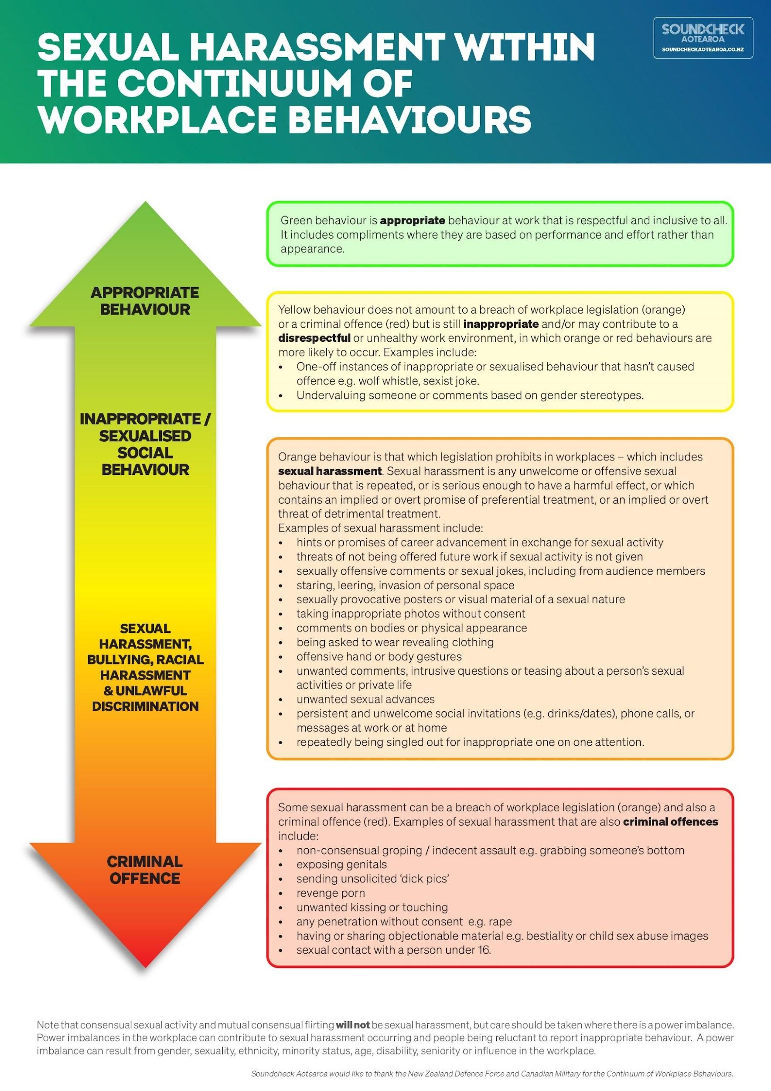

Appendix 1: Flowchart
GUIDANCE: As set out in the Policy, you should decide whether you want to include this (or any other) flowchart. If you include it in your policy, you must follow the process for any report of sexual harassment you receive.
There is a more detailed flowchart on the SoundCheck Website which you may want to refer to for guidance if making or receiving a disclosure of sexual harassment.
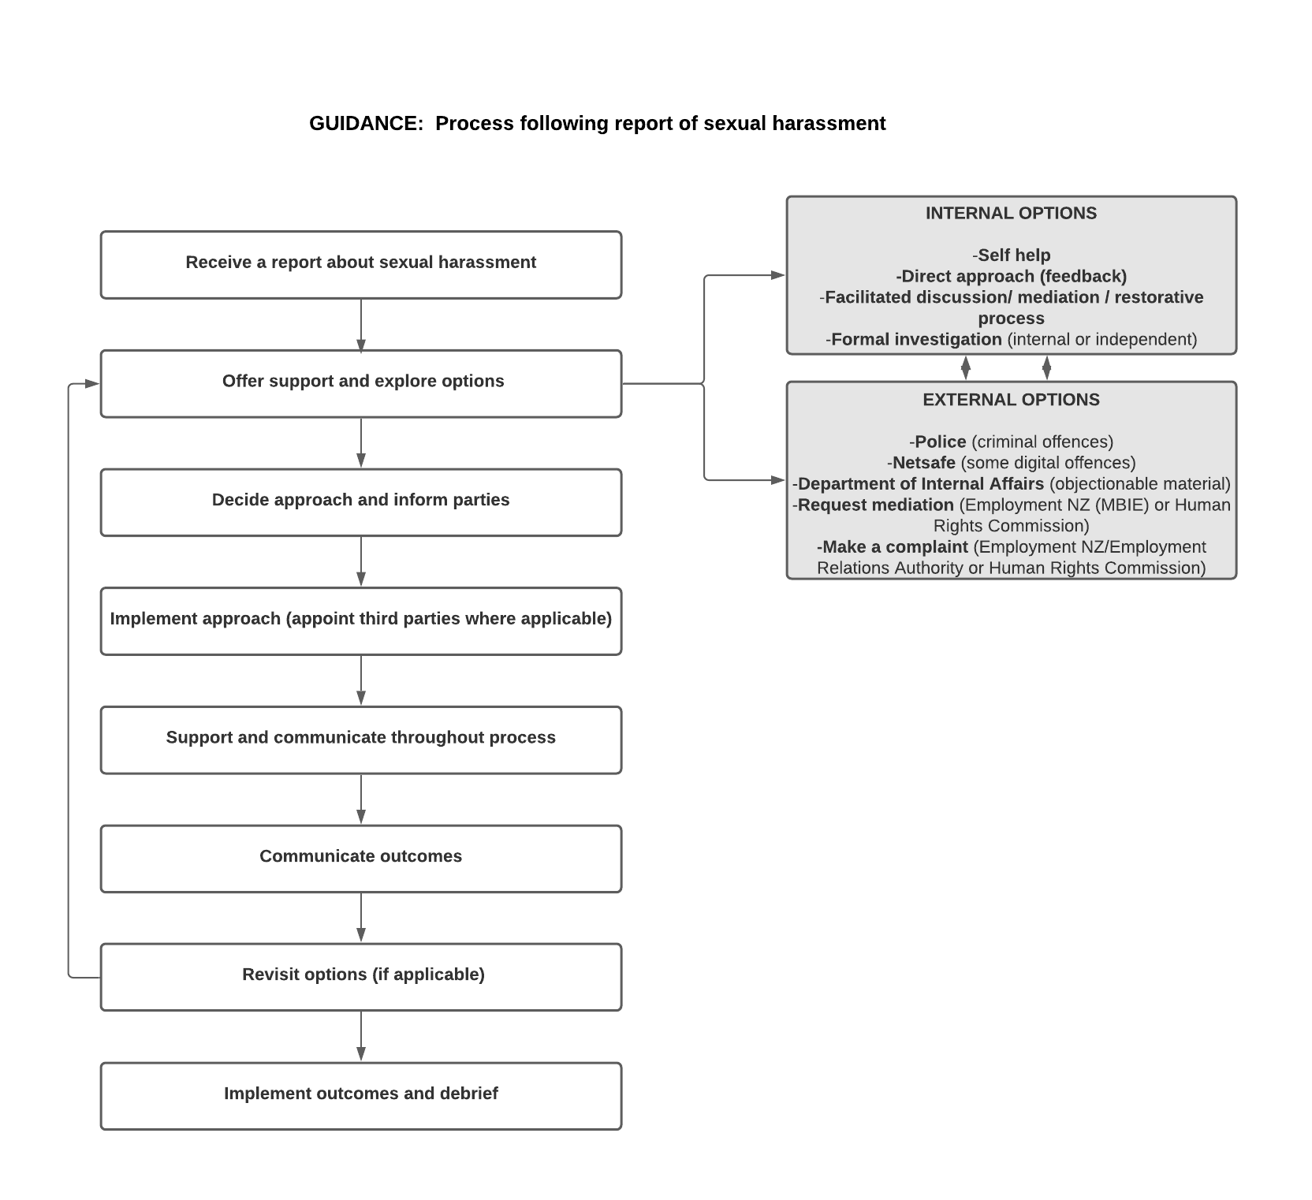

Appendix 2: Reporting form
This form can be used by someone experiencing or seeing sexual harassment and is designed to give you guidance about what information to include when making a report of sexual harassment. Before making a report, you may wish to refer to our Sexual Harassment Policy which outlines the processes we may take, options that are available to you and our approach to confidentiality.
Please note:
- You can ask someone you trust to help you fill it in.
- If you prefer you can use this form as a guide for the information required to draft an email or have a conversation.
- It is helpful to have your report written down as this makes it easier for those considering it to ensure they have all the information and that they haven’t missed anything.
- Give the completed form to: [insert name of relevant person in the organisation].
GUIDANCE: Whoever is listed here should replicate whoever is listed in the Reporting/Complaints section of the policy.
If you make a report of sexual harassment, we will discuss the options with you before any steps are taken or information is disclosed to the person the allegations are about.
Please note that a formal investigation will require a disclosure of the information you provide below and subsequently to the person it is about.
Full name:
Position within the organisation:
Preferred contact method:
Provide your phone number and/or email address and let us know how you would prefer we contact you (e.g. text, call etc.)
When did the incident(s) happen: (date and time)
Is it still ongoing?
Provide as many details as you are comfortable to share about the incident(s), for example:
- Where did it occur?
- Who was present?
- What was said or done? Who by? What’s their role?
- Who witnessed this incident?
- How has this affected you?
- Have you taken any actions? If so, what?
- What would you like to happen next?
Please note this form is to assist you in reporting your concerns internally. Although we have used the example form developed by SoundCheck Aotearoa, they cannot receive reports under this policy.

- I understand that I can seek help or advice to complete this form.
- I declare to the best of my knowledge the information provided in this form is true and correct.

Name:
Date:

See section 108 of the Employment Relations Act 2000 (applies to employees) or section 62 of the Human Rights Act 1993 (applies to contractors and employees).
See Sexual Harm and Consent section of the SoundCheck Aotearoa website for more information on criminal offences.
The age of consent in New Zealand for sexual activity is 16 years.

